Sennheiser @ ISE 2026



Discover Seamless Collaboration with Sennheiser at ISE 2026

Wedemark, Germany - January 28, 2026 – Sennheiser, the first choice for advanced audio technology that makes collaboration and learning easier, will highlight its growing ecosystem of industry partnerships and alliances at Integrated Systems Europe (ISE) 2026 in Barcelona, Spain, February 3 - 6.

At this year’s ISE, the Business Communication Zone at Sennheiser booth 3B500 will feature a touchscreen experience, allowing visitors to explore an interactive overview of the partners and technologies shaping the next wave of collaboration. The experience illustrates how Sennheiser solutions work with its partner ecosystem to support simpler integration and enable smarter, more flexible spaces.

Across the show floor, integrators, consultants, and end users can discover how Sennheiser solutions work alongside complementary technologies within Sennheiser’s global partner ecosystem. Sennheiser products will be featured on 20 partner booths, including Airtame, Barco, Crestron Datavideo, Laia, Lightware, Lumens, MAXHUB, Q-SYS, Xilica, and more. In addition, 23 partners are taking part in Sennheiser’s in-show campaign, the Sennheiser ISE26 Hunt, which encourages visitors to explore combined solutions across the ecosystem in a fun, interactive way.

New Collaborations in the Spotlight
New and expanded collaborations across Sennheiser’s global partner ecosystem will be highlighted around ISE 2026, reflecting continued momentum across intelligent audio, video, and room system integrations.
On the show floor, visitors can learn more about the recently announced Barco ClickShare Hub room system bundles featuring Sennheiser TeamConnect Bar solutions certified for Microsoft Teams.

ISE 2026 will also mark an expansion of Sennheiser’s collaboration with Crestron, with further information available at the Crestron booth. There, visitors can learn more about the integration of Crestron’s newly announced DM NAX Intelligent Audio system with the Sennheiser TeamConnect Ceiling Medium microphone.
In addition, Sennheiser is extending support for intelligent camera tracking applications through new collaborations with Laia and Vaddio, both of which will be exhibiting at the show. Separately, Pleneo and Sennheiser will have news about a new collaboration supporting consistent, AI-ready collaboration experiences via a unified room platform for medium and large meeting spaces.
Beyond the show floor, Sennheiser is expanding its collaboration with AVer through the recently announced integration between EW-DX and the AVer MT300(N) Matrix Tracking Box, building on existing support for Sennheiser TeamConnect Ceiling microphones and extending intelligent audio workflows across both wireless and ceiling microphone solutions.

Join the Hunt 2026
The Sennheiser ISE26 Hunt invites attendees to explore Sennheiser’s partner ecosystem in a simple, interactive way. Using the Scavify app, participants can visit partner booths, complete quick tasks, and discover how Sennheiser solutions work alongside complementary technologies across meeting and learning spaces. As participants take part, completed challenges earn points that contribute to their chances of winning prizes.
Designed for integrators, consultants, and technology users, the Hunt offers a practical way to understand how Sennheiser’s ecosystem supports connected, flexible environments across classrooms, boardrooms, and collaboration spaces.

Visitors to ISE can join in the Hunt by completing the following steps:
1. Download the Scavify app from the Apple App Store or Google Play
2. Search for ISE26 and enter the Hunt
3. Complete the Q&A challenges to get started, then continue the Hunt by visiting partner booths and completing QR, photo, and video challenges to earn points
4. Visit the Sennheiser booth reception (3B500) at any point after completing the Q&A challenges to collect your Sennheiser socks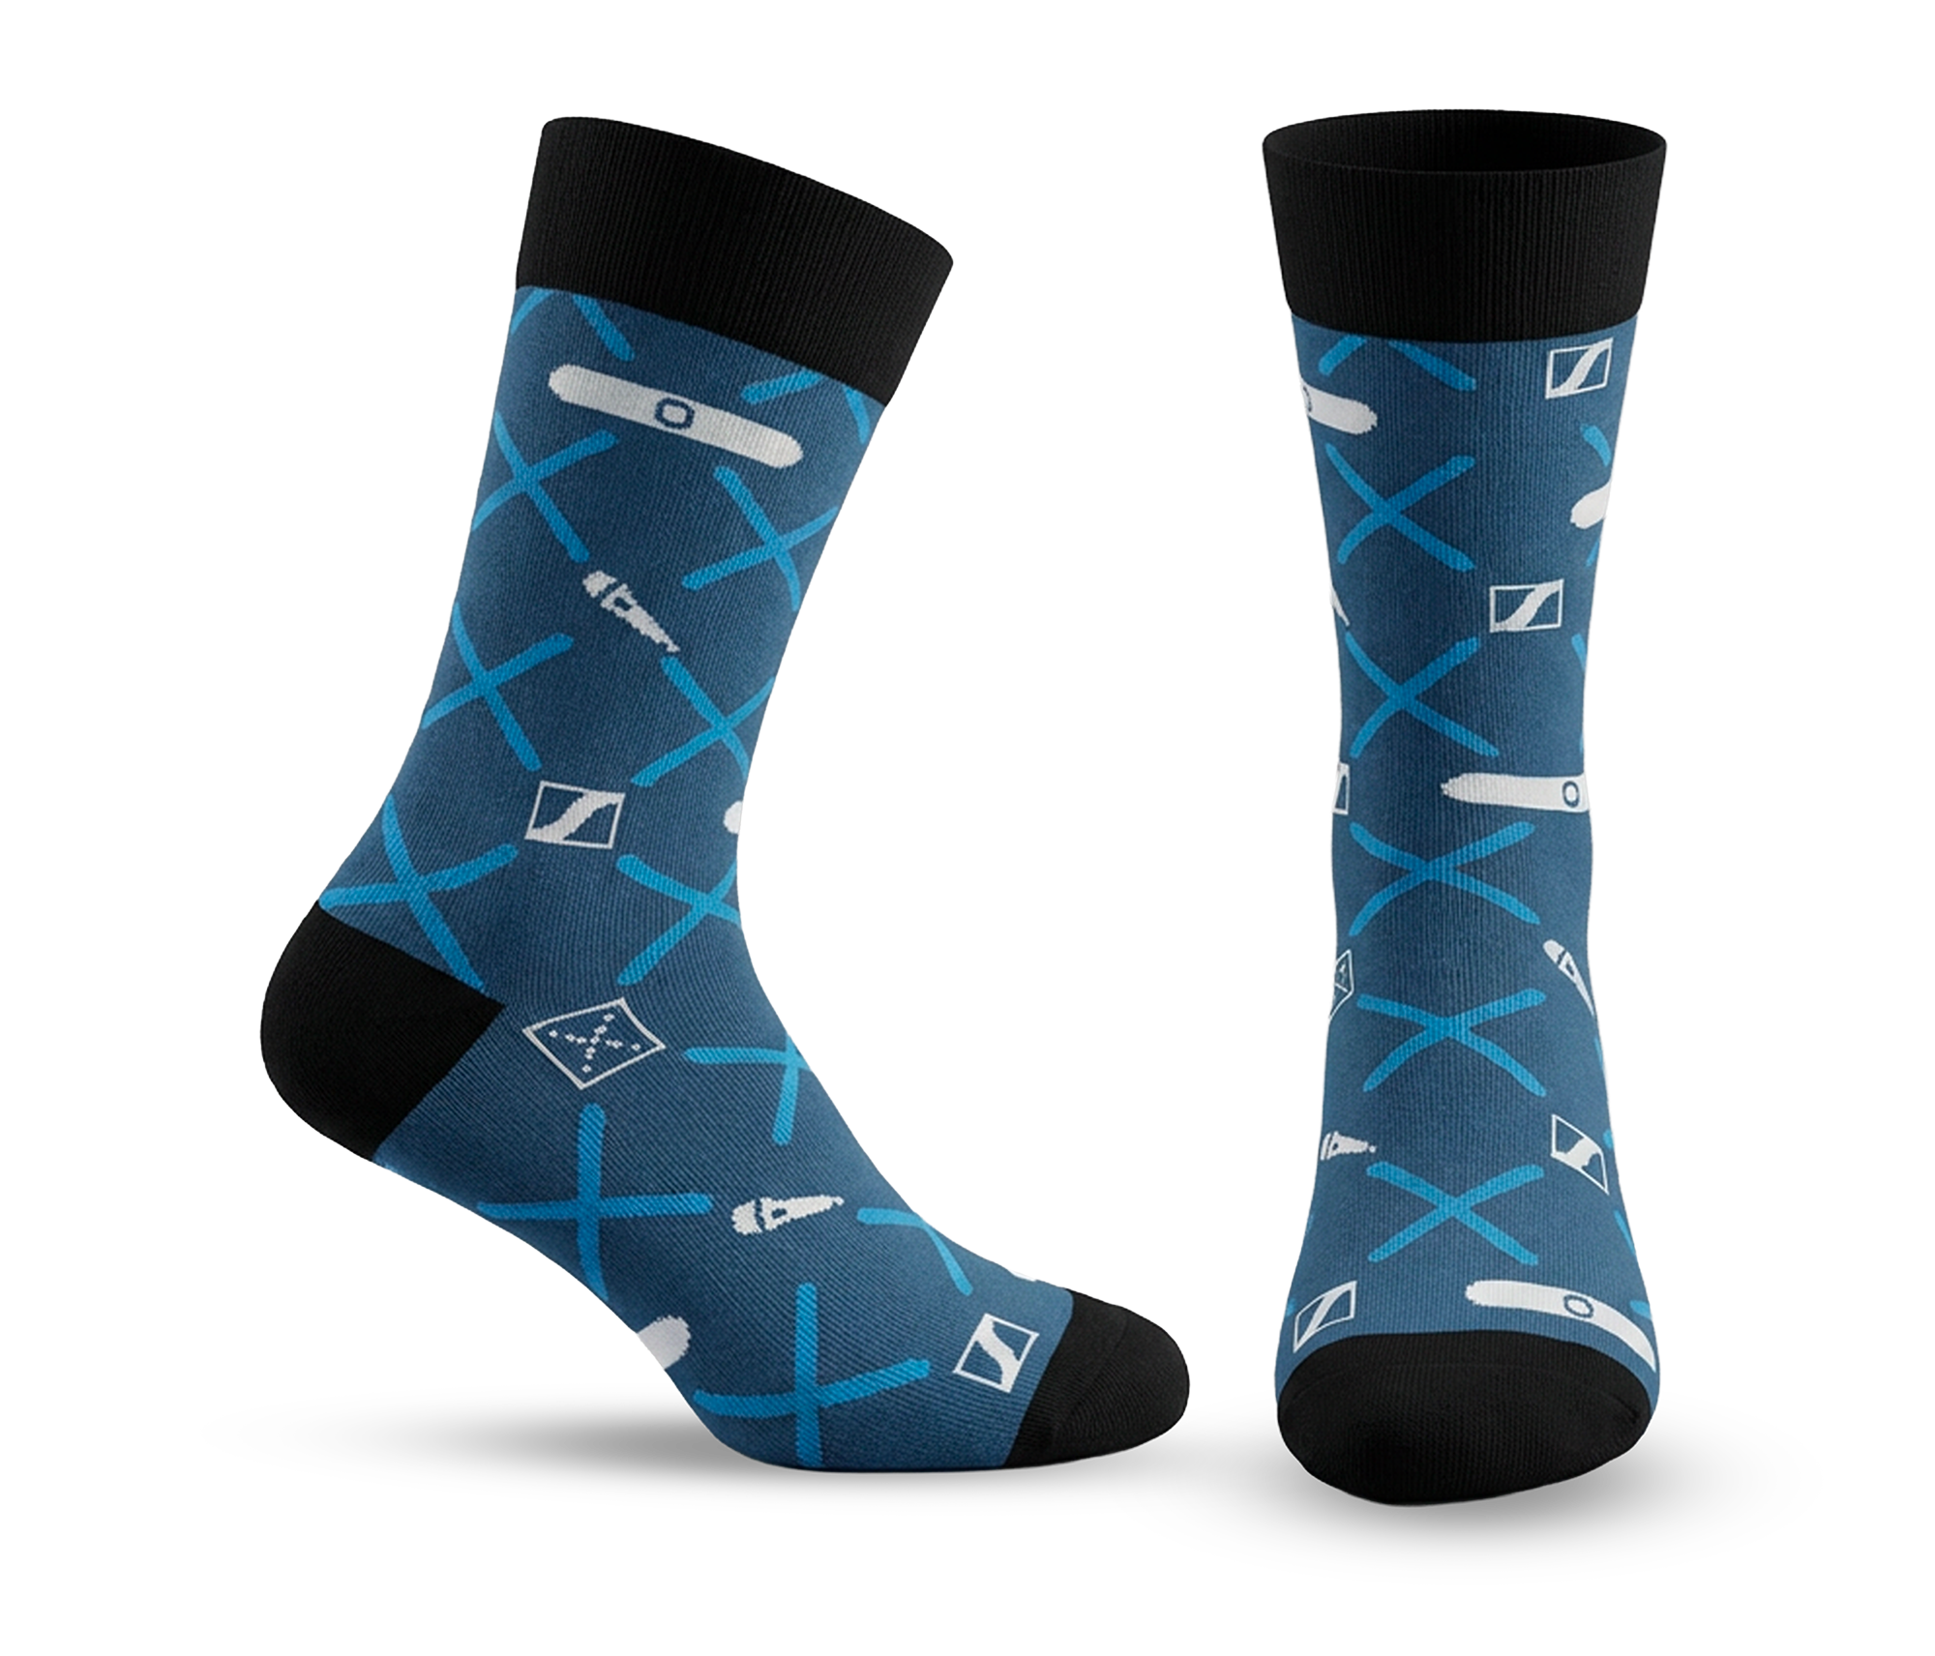
As the Hunt continues, participants can build their score through QR and photo-based challenges across the show floor. Selected partner booths also feature photo-based challenges, giving participants the chance to win additional prizes offered by Sennheiser’s ecosystem partners.
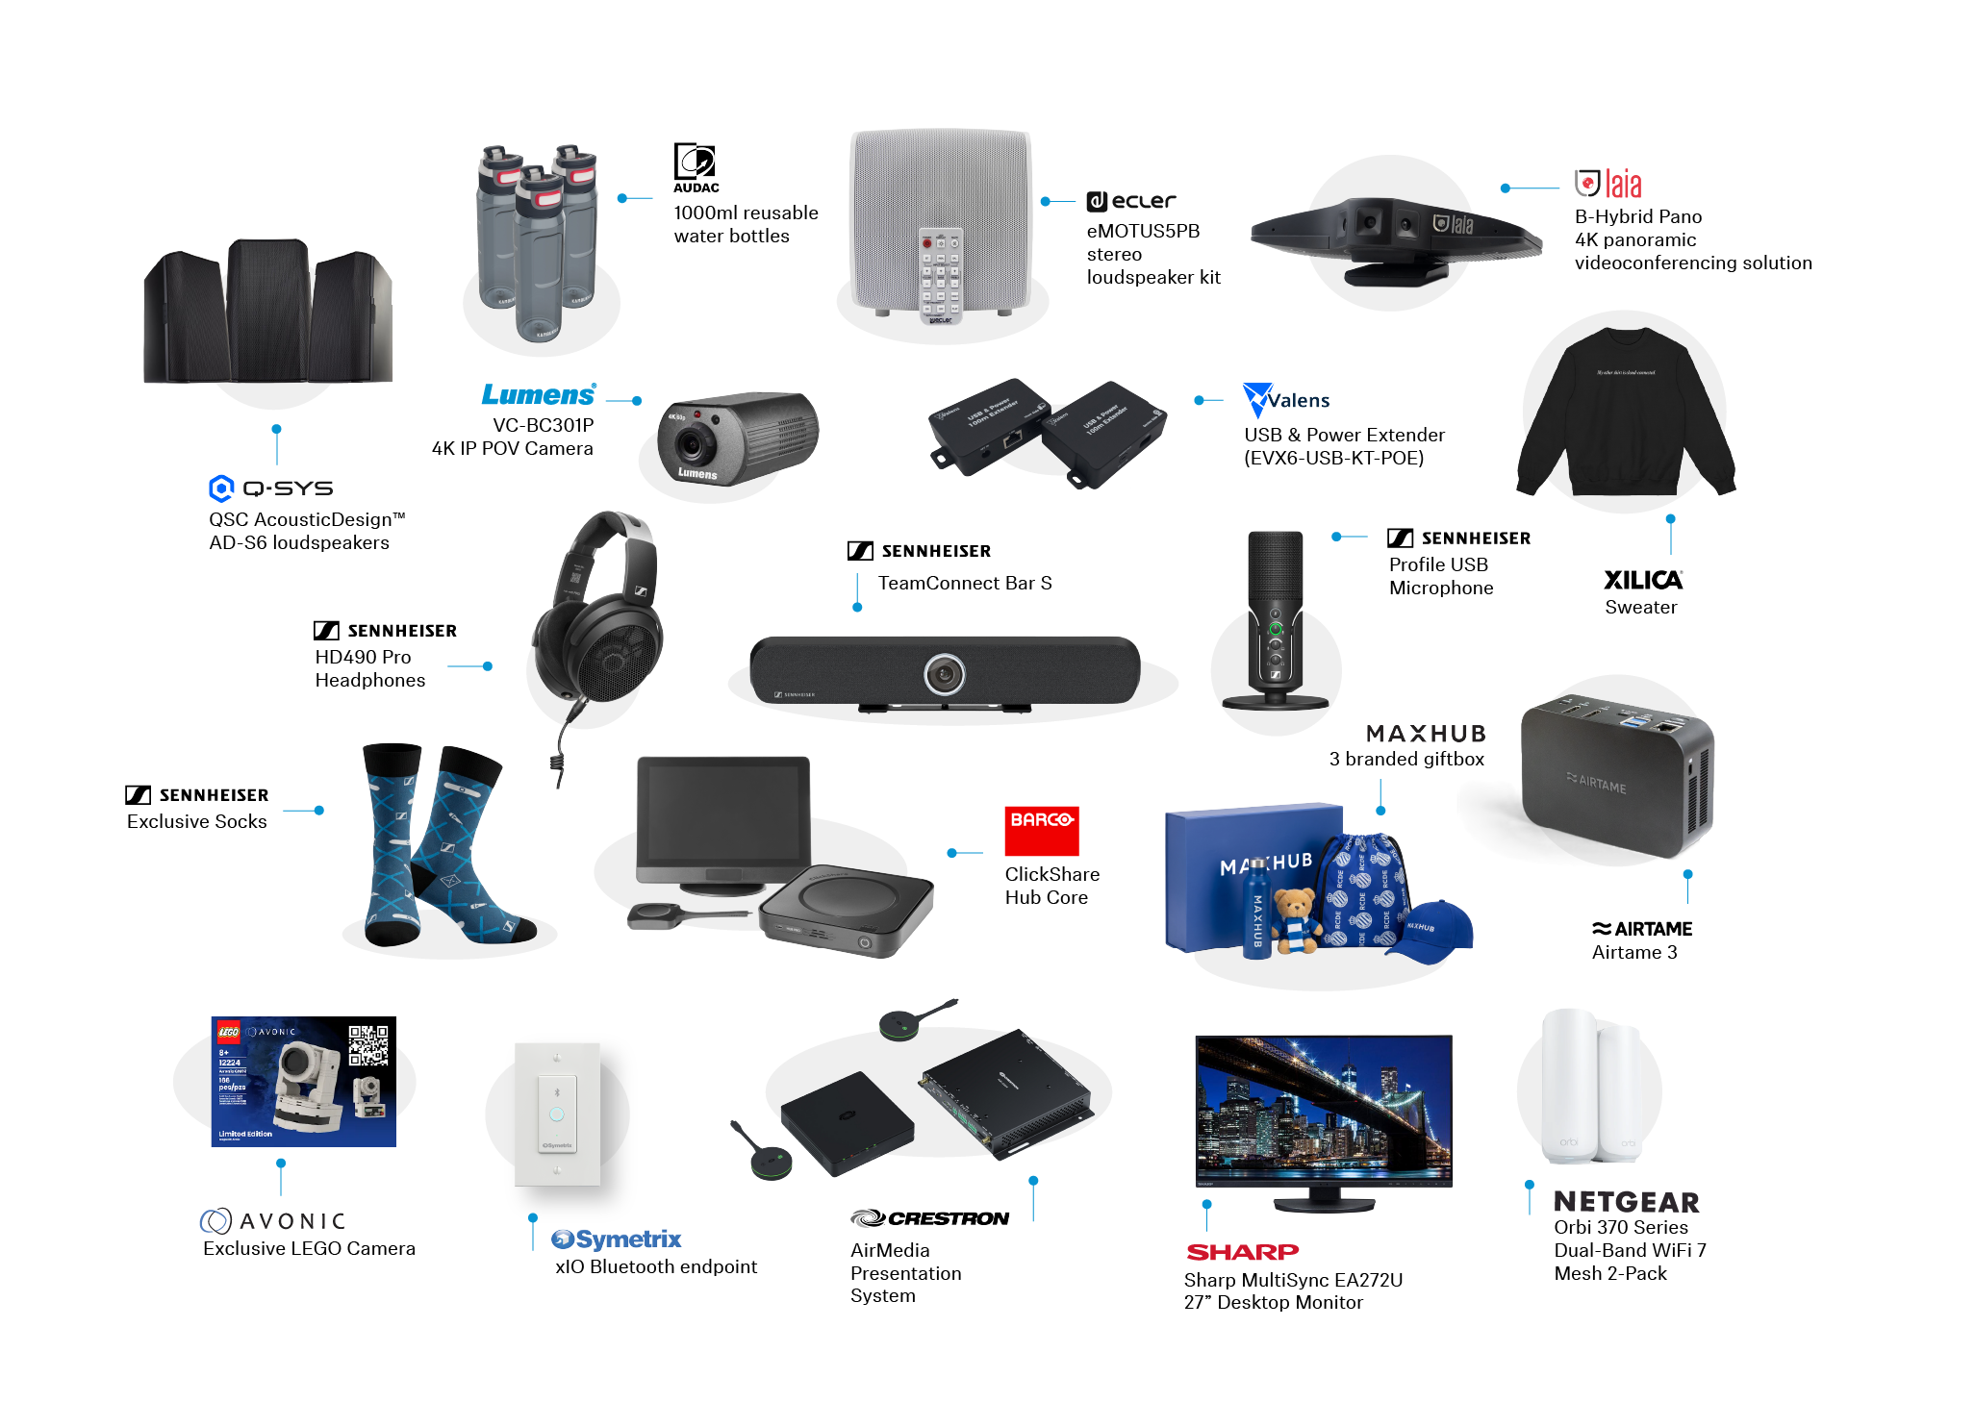
.
More information about Sennheiser’s partner and alliance activity at ISE can be found here.

About the Sennheiser brand
We live and breathe audio. We are driven by the passion to create audio solutions that make a difference. Building the future of audio and bringing remarkable sound experiences to our customers – this is what the Sennheiser brand has represented for more than 75 years. While professional audio solutions such as microphones, meeting solutions, streaming technologies and monitoring systems are part of the business of Sennheiser electronic GmbH & Co. KG, the business with consumer devices such as headphones, soundbars and speech-enhanced hearables is operated by Sonova Holding AG under the license of Sennheiser.

www.sennheiser.com
www.sennheiser-hearing.com

Global Press Contact
Jeff Horan
+1 860-598-7539
jeffrey.horan@sennheiser.com

